

LjunggrenAudio RYO PATHS
A Cycling Sequential Switch

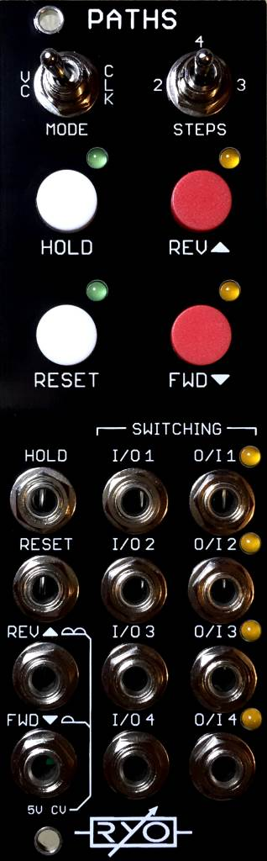

- 4:4 cycling sequential switch.
- simultaneous forward/reverse stepping, hold, reset.
- voltage controlled mode based on the same design as our VC Sequencer.
- push buttons for each function.
- All analogue circuitry - no software or micro processors!
- All low latency CMOS and Opamp circuitry!
- essentially four separate switches that are commonly controlled and shared ins and outs.
- schmitt trigger inputs.
- slim 8HP footprint.
- compact 46mm Depth (with power cable attached).
- low power draw: 30mA +12V / 8mA -12V / 0mA +5V.
- Works for audio as well as CV.
- Fast responding CV inputs allow clocking to reach through entire audio range.

downloads
* user manual
* quickstart guide
* assembly guide
* hi-res schematic
* datasheet
* BOM

